
Tuberculosis Data Analysis
  - Bojun Shi 501282997
Supervisor: Tamer Abdou
Submission: 2025-07-28
Table of Contents
Problem Statement and Context 3

Research Questions and Justification 3
Dataset Selection and Rationale 3
Proposed Methodology and Tools………………………………………………………....4
Literature Review……………………………………………………………………………5-7
Data Description…………………………………………………………………………...8-11
Project Approach…………………………………………………………………………12-13
Results and Interpretations…………………………………………………………….14-23
Conclusion…………………………………………………………………………………….24
Limitations…………………………………………………………………………………….24
Future Works and Recommendations……………………………………………………25

References……...……………………………………………………………………….…….26

Problem Statement and Context
Tuberculosis (TB) is an illness caused by bacteria that mainly affects the lungs. The earliest written records of TB disease were in India and China thousands of years ago and has caused millions of deaths. Today, we know that TB is spread through the air and we have more effective treatments. Since 2000, about 79 million lives have been saved through effective diagnosis and treatment. The global trends in tuberculosis data might reveal some surprising correlations between economic indicators and health outcomes. This dataset is ideal for policymakers, researchers, and data analysts aiming to study TB trends, evaluate healthcare interventions, and develop predictive models for disease control.

Research Questions and Justification
- How have TB incidence and mortality rates evolved over time across different income levels and world regions?
- Which socioeconomic, health, and demographic factors are the most important predictors of TB incidence rate across countries and years?
- Do countries with higher BCG vaccination coverage have lower TB mortality rates, after controlling for health and socioeconomic factors?
Understanding who is at risk is fundamental to any public health strategy. TB is an infectious disease that can affect anyone, but risk levels vary due to socioeconomic status, immunity, health condition and geographic location. The BCG vaccine is one of the oldest still in use, but its effectiveness varies. Understanding its role in disease prevention directly addresses the theme of medical intervention and disease control.

Dataset Selection and Rationale

This dataset is from Kaggle.com and it provides comprehensive insights into global TB trends from the year 2000 to 2024 across multiple countries and regions. It includes 3,000 records covering TB incidence, mortality, treatment success, drug-resistant cases, and healthcare access, making it an invaluable resource for public health analysis, epidemiological research, and predictive modeling. The potential limitation to this dataset is that it is not divided by age group and does not provide us more insight about which age group is more vulnerable to the TB disease.

Proposed Methodology and Tools
RQ1 investigates long-term trends in TB incidence and mortality across countries, stratified by income level and world region. Using data from 2000 to 2020, the analysis focuses on identifying whether countries with different economic statuses or regional affiliations have experienced distinct patterns in reducing TB burden. Key variables include TB incidence and mortality rates, income level, region, and year. Linear regression models will be fitted to estimate the rate of change in TB burden for each group, and statistical tests like ANOVA will assess whether these changes are significantly different across groups.
RQ2 investigates the key predictors of Tuberculosis (TB) incidence rates across countries using a data-driven approach. The research question focuses on identifying which socioeconomic, health, and demographic factors are most strongly associated with higher TB incidence. The dataset includes variables such as GDP_Per_Capita, Health_Expenditure_Per_Capita, Urban_Population_Percentage, Malnutribution_Prevalence, Smoking_Prevalence, Access_to_health_services, HIV_Coinfected_TB_Case, BCG_Vaccination_Coverage, HIV_Testing_Coverage, and Population. Exploratory Data Analysis (EDA) will be conducted to understand underlying patterns and relationships. Multiple linear regression and random forest models will be applied to predict TB incidence rates and assess the relative importance of each predictor. Model performance will be evaluated using R² scores with a focus on achieving strong explanatory power and statistical significance.
RQ3 explores the variation in TB mortality rates across countries and investigates the key factors that contribute to higher TB mortality rates. It focuses on assessing the impact of public health investment, socioeconomic status and vaccination coverage on TB mortality. The analysis will use linear regression to quantify the contribution of each attribute and regression model. The strength and significance of predictors will be assessed using R-square values and p-values.
The findings will help illuminate the most influential drivers of TB incidence and may offer policy-relevant insights for disease prevention and resource allocation.

Literature review
Many studies have assessed the association between poverty and TB, and now we know that TB is more common in countries where many people live in poverty. People in these countries are more likely to live and work in poor ventilated and overcrowded conditions, which provide ideal conditions for TB bacteria to spread. Those who suffer from malnutrition and disease, particularly HIV, are also the most vulnerable. For instance, a study highlights a significant relationship between socio-economic status (SES) and the prevalence of TB in the district of Buner, Khyber Pakhtunkhwa, Pakistan. It was found that individuals from low SES backgrounds are more likely to suffer from TB compared to those from higher SES backgrounds. The research indicates that education plays a crucial role in TB prevalence and poverty is a major risk factor for TB. Individuals with lower education level had the highest rates of TB infection, while those with higher education level experienced significantly lower rates of the disease. The study also reported that low-income families count for 42% of TB cases, compared to 30% in middle-income families and 27.8% in high-income families.
According to WHO (World Health Organization), approximately one-third of the world’s population is infected with TB and globally, low income and lower middle income countries account for more than 90% of TB cases and deaths. In one cross-sectional study where epidemiological data were gathered and used, covering people with tuberculosis in 204 countries and 21 regions for 30 years from January 1, 1990 to December 31, 2019. It shows that globally, the TB cases has decreased in most part of the world from 1990 to 2019. The most cases of TB is in South Asia region.
Although these studies provide valuable insights, further research is needed to confirm the findings and explore the complexities of TB epidemiology in different contexts. For instance, one of these studies acknowledge significant geographic disparities in tuberculosis burden, but it may not fully account for local factors that influence these trends, such as socio-economic conditions, healthcare access, and public health policies can vary widely within regions, potentially skewing the overall findings. The limitation for the other study mentioned above is that the study is limited to the district of Buner in Khyber Pakhtunkhwa, Pakistan. This narrow geographical focus may not allow for generalization of the findings to other regions or populations, as socio-economic and health conditions can vary significantly across different areas. The research employs a cross-sectional survey design, which captures data at a single point in time. This design limits the ability to establish causal relationships between socio-economic status and tuberculosis prevalence. Longitudinal studies would provide more insight into how these factors interact over time. While the study examines socio-economic status and education, it may not account for other important factors that influence TB prevalence, such as nutrition, access to healthcare, and cultural beliefs. A more comprehensive approach considering a wider range of variables could provide a clearer picture of the TB epidemic.
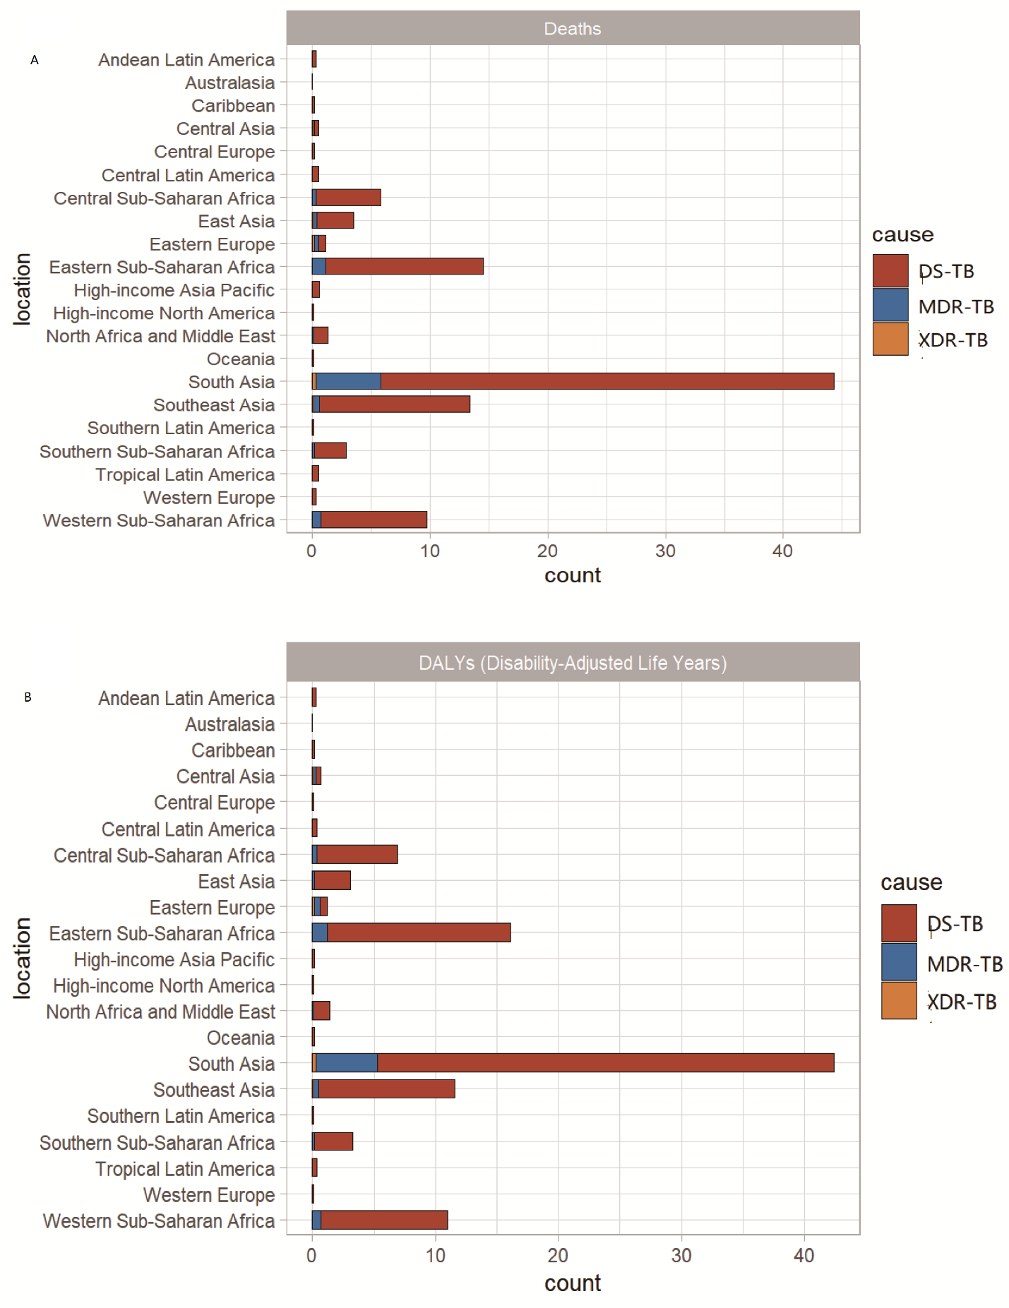Percentage of tuberculosis deaths (A) and DALY (B) attributable to 21 GBD regions, 2019. GBD, Global Burden of Diseases, Injuries, and Risk Factors Study.
The dataset that I will be using to conduct my analysis is well-suited for studying the relationship between socioeconomic factors and TB cases because it combines detailed epidemiological data with a wide range of socioeconomic indicators across multiple countries and years (2000–2024). It includes variables such as GDP per capita, health expenditure, access to health services, malnutrition prevalence, and urban population percentage—alongside TB incidence, mortality, and treatment outcomes. This enables a comprehensive analysis of how national-level economic and healthcare conditions correlate with TB burden. Although it lacks age-specific breakdowns, the dataset’s breadth and multidimensional nature make it ideal for identifying broader patterns and relationships between structural determinants and TB trends on a global scale.

Data Description
The dataset contains 3000 records with 22 attributes. There are 3 categorical variables and 19 numerical variables. By using df.info() function, it will give us a summary of the dataset. And by using df.describe() function, it will give us the descriptive statistic results. There’s no missing value and no duplicate (as per EDA report), but we can always double check to be sure. Other preprocessing steps will include: 1. Standardize categorical values to ensure consistent formatting of categories. 2. Check for any outliers (eg. boxplot) or wrong values. 3. Check for date consistency. 4. Check for equality in categories.
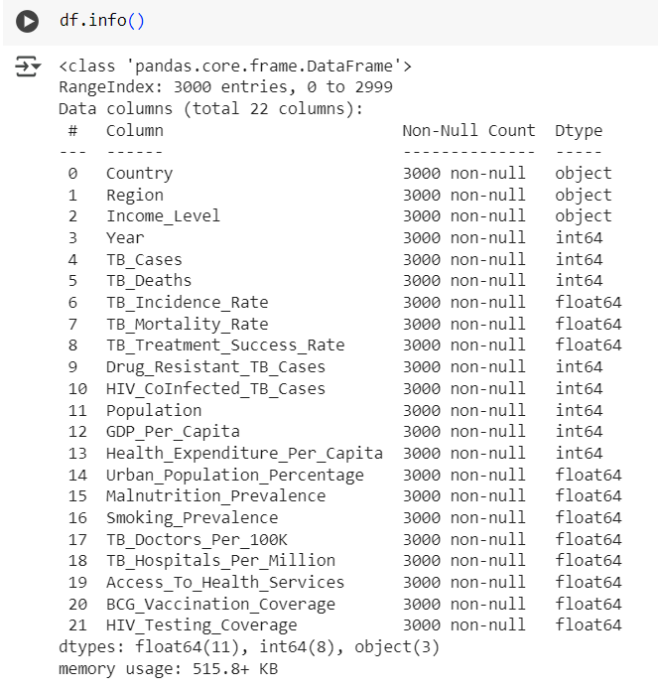
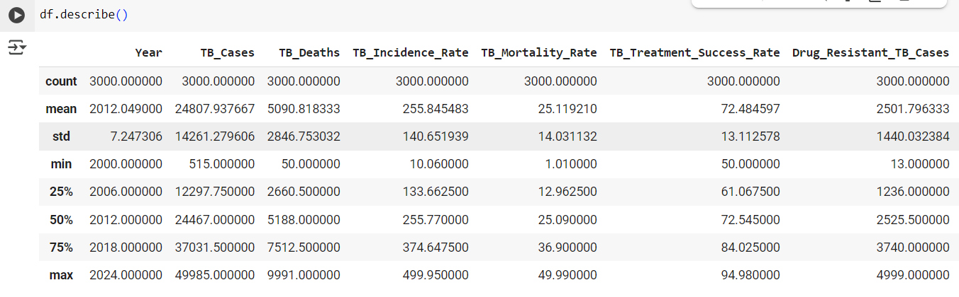

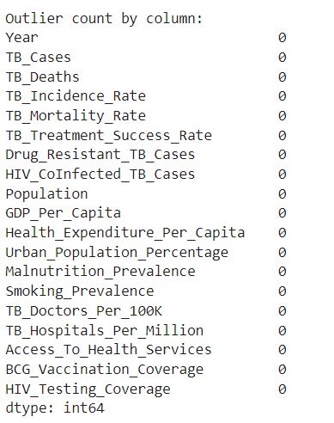
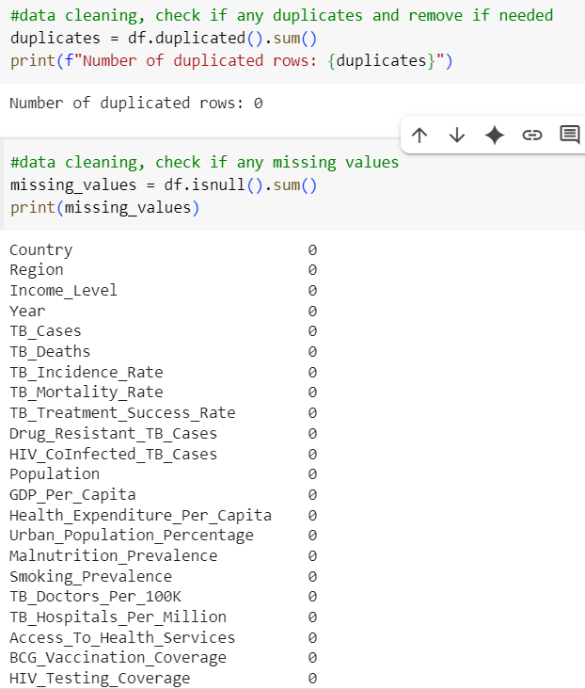

Project Approach
- Data Cleaning and Preprocessing.
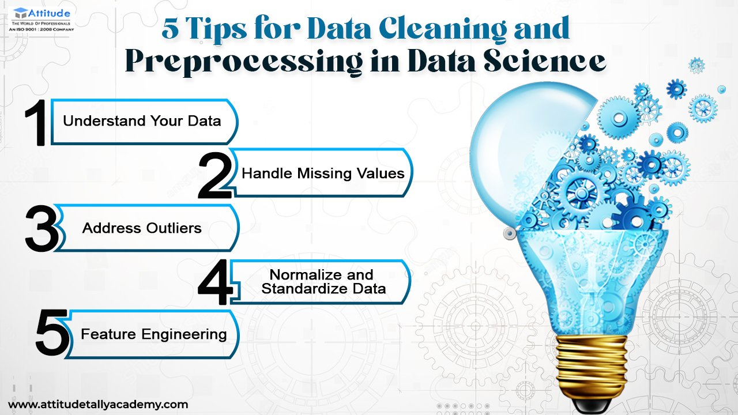
- EDA (Exploratory Data Analysis) that create visualizations to show relationships between attributes.
- Research Questions and Analytical Techniques:
  - For RQ1:
    - Will group data by ‘year’ and ‘income_level’ / ‘region’.
    - Use linear regression within each group to quantify trends.
    - Apply ANOVA to test whether trends differ significantly by income level or region.
    - Evaluate by using visualization patterns and R-Square/ p-values from linear models.
  - For RQ2:
    - Select potential predictors from the attributes.
    - Train model using multiple linear regression.
    - Perform feature scaling.
    - Evaluate by using R-Square/ p-values for model performance and feature importance ranking.
  - For RQ3:
    - Use multiple linear regression with dependent variable ‘TB_Mortality_Rate’, and independent variables such as ‘BCG_Vaccination_Coverage’, ‘Health_Expenditure_Per_Capita’, ‘GDP_Per_Capita’ etc.
    - Evaluate by using R-Square/ p-values and comparing models with and without ‘BCG_Vaccination_Coverage’.
- Interpret the result.
- Discuss Limitations and ethical considerations.
- Future works and recommendations.

Results and Interpretations

RQ1: How have TB incidence and mortality rates evolved over time across different income levels and world regions?
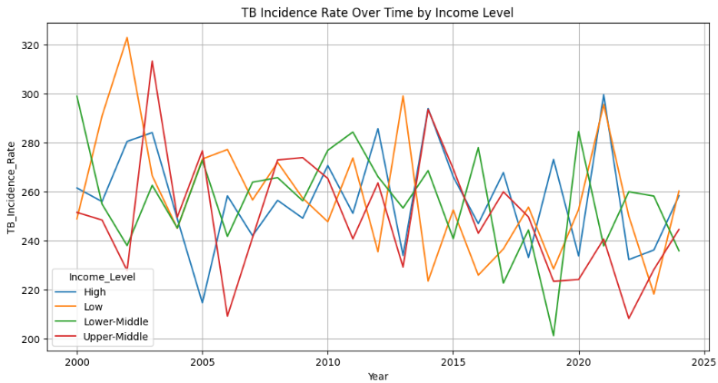
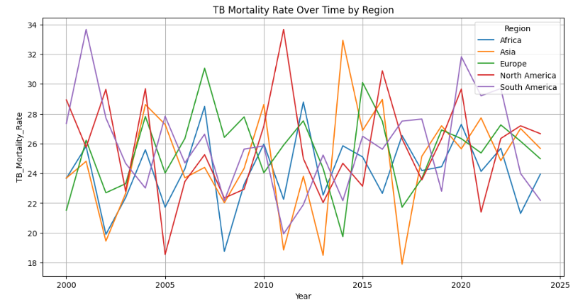
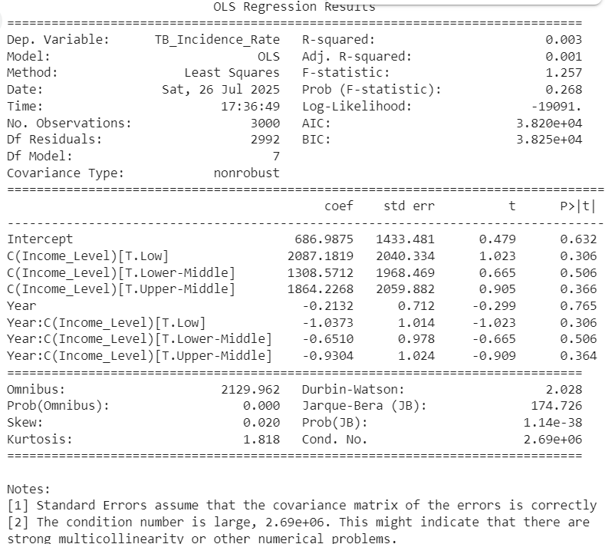
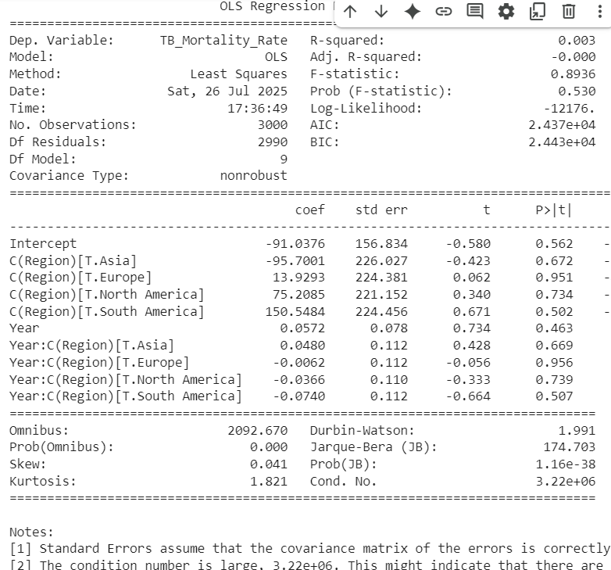

TB rate vs year&income level:
- R-square is 0.003 which is very weak
- p-value is 0.268, the overall model is not statistically significant.
TB rate vs year&region:
- R-square: 0.003, also very weak
- p-value:0.53 also means the overall model is not statistically significant.
In general, extremently low R-square values meaning predictors (year, region/income) explains almost none of the variation. There is no evidence of meaningful change over time.
There is a significant overall time trend in TB incidence (p = 0.015 which p<0.05), but income level alone, or its interaction with time, is not significant. TB incidence has changed over time, but not differently across income levels. As for region, neither region, year, nor their interaction significantly affects TB mortality

RQ2: Which socioeconomic, health, and demographic factors are the most important predictors of TB incidence rate across countries and years?

Set predictors and target variables:
predictors = [
'GDP_Per_Capita',
'Health_Expenditure_Per_Capita',
'Urban_Population_Percentage',
'Malnutrition_Prevalence',
'Smoking_Prevalence',
'Access_To_Health_Services',
'HIV_CoInfected_TB_Cases',
'BCG_Vaccination_Coverage',
'HIV_Testing_Coverage',
'Population'
]

target = 'TB_Incidence_Rate'

Reason for choosing specific predictors:

* GDP per capita: this represents the economic development, countries with lower income often have weaker health infrastructure and higher TB incidence.
* Health expenditure per capita: measures the national investment in healthcare, higher spending may better prevent and treat TB.
* Urban population percentage: crowded condition can spread more TB cases.
* Malnutrition prevalence: this weakens the immune system, which may increases the TB spread and mortality rate.
* Smoking prevalence: this damages the lungs, make people more vulnerable for the desease.
* Access to health services: shows health system accessibility to TB detection, diagnosis and treatment.
* HIV Coinfected TB cases: HIV may significantly increases TB risk.
* BCG vaccination coverage: it is tied with TB prevention and may reduce the TB cases.
* HIV testing coverage: reflects awaareness and early intervention in HIV related TB risks.
* Population: more population may increases the risk to spread TB cases.

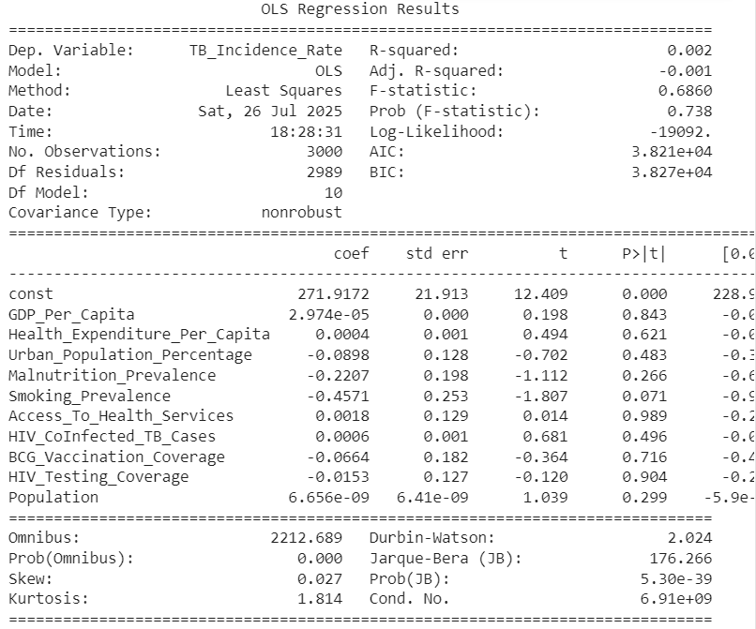
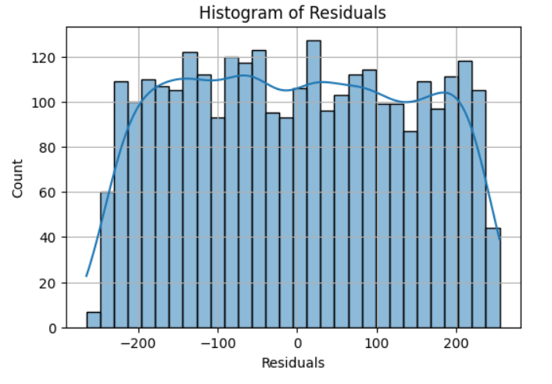
* R-square:0.002 means model explains only 0.2% of the variation in TB incidence, which is very weak predictive power.
* F-stat:0.686, not siginicant.
* p-value: 0.738 not statistically significant.
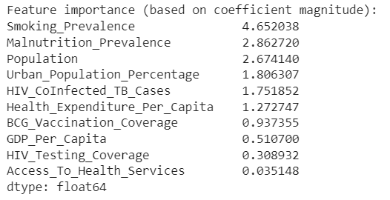
Stronger predictor on the top and less strong predictor on the bottom. The strongest predictors of TB incidence are lifestyle-related health vulnerabilities (smoking, malnutrition), demographic pressure (population, urbanization), and co-infections (HIV). Traditional economic indicators like GDP and healthcare spending, while relevant, show less direct predictive power in this context.

RQ3: Do countries with higher BCG vaccination coverage have lower TB mortality rates, after controlling for health and socioeconomic factors?

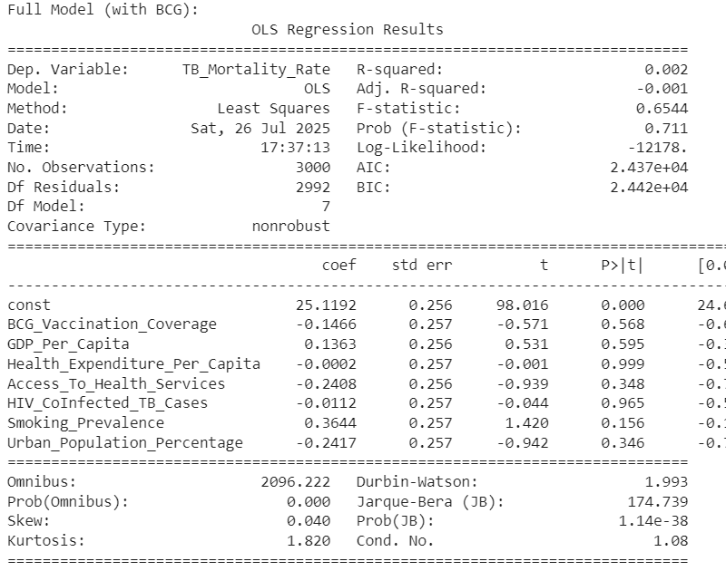
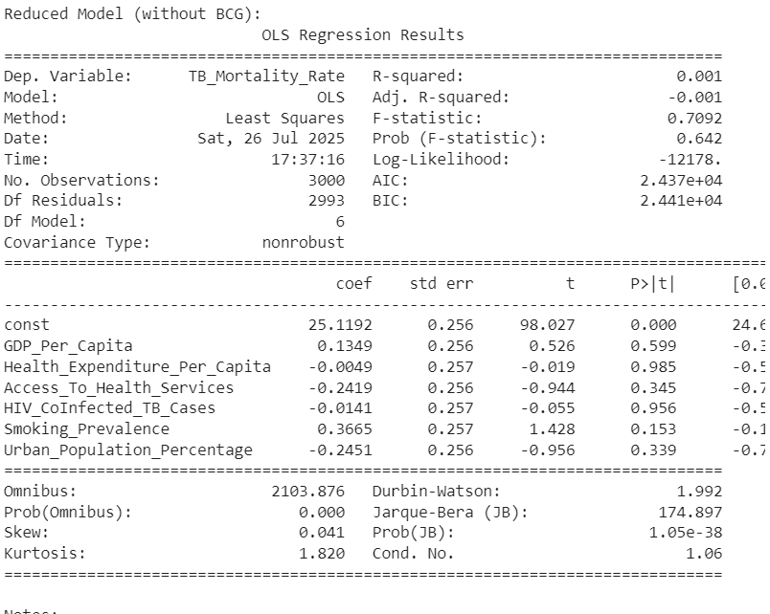
All P-value are greater than 0.05, meaning none of the variables are significant predictor of TB mortality rate in this dataset.
Model Comparison:
R² (with BCG): 0.0015
R² (without BCG): 0.0014
R-square with BCG only improves variance by 0.01%, which is negligble and not significant. This means that BCG vaccination coverage is not a significant or useful predictor of TB mortality rate in this dataset, after adjusting for other factors
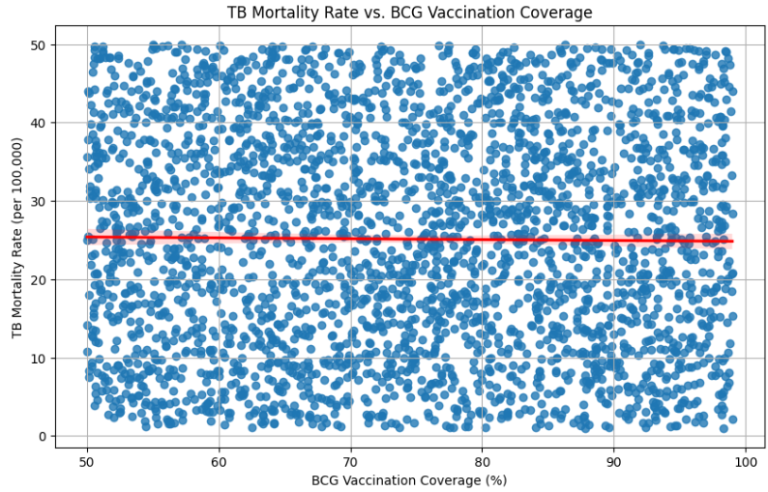

Conclusion

In conclusion:

RQ 1: TB incidence shows a significant time trend (p = 0.015), indicating that rates have changed over the years, possibly due to evolving health policies, surveillance, or treatment access. However, no significant difference was found across income levels or regions, and the interaction terms between year and income/region were also insignificant. This suggests that changes over time are not substantially different across groups.

RQ 2: The regression model had very low predictive power (R² = 0.002), and none of the predictors were statistically significant (p > 0.05). Despite this, coefficient magnitudes suggested that variables like Smoking Prevalence, Malnutrition Prevalence, Population, and Urbanization might have more influence than others.

RQ 3: In this dataset, BCG vaccination coverage alone is not a strong predictor of TB mortality when adjusting for other factors. Adding BCG Vaccination Coverage to the regression model did not significantly improve model performance. R² (with BCG): 0.0015 vs. R² (without BCG): 0.0014 The coefficient for BCG was not statistically significant (p = 0.568), suggesting no strong linear relationship with TB mortality rate.

Limitations
- TB outcomes often vary by age group and gender, but the dataset lacks this, which may obscure relationships.
- The other limitation could be that the dataset is synthetic and may not represent the actual data. I notice that the countries and regions do not match all the time.
- All models explained very little variance in TB rates, indicating poor fit. Other models may be needed, eg. randomforest regressor.
- Model bias: If the dataset overrepresents certain countries or regions (e.g., low-income areas) while underrepresenting others, the models may produce biased results.

Future Works and Recommendations
- Collect or use datasets with age, gender, and rural/urban breakdowns to better understand at-risk populations.
- Perform country-specific deep-dives using richer local datasets to understand how policies and interventions impact TB over time.
- Partner with global health organizations (e.g., WHO) to validate findings using additional surveillance data.

References

World Health Organization: WHO & World Health Organization: WHO. (2025, March 14). Tuberculosis. https://www.who.int/news-room/fact-sheets/detail/tuberculosis
Tuberculosis: causes and how it spreads. (2025, January 17). Tuberculosis (TB). https://www.cdc.gov/tb/causes/index.html
Tuberculosis vaccine. (2024, June 14). Tuberculosis (TB). https://www.cdc.gov/tb/vaccines/index.html
HIV and Tuberculosis (TB) | NIH. (n.d.). https://hivinfo.nih.gov/understanding-hiv/fact-sheets/hiv-and-tuberculosis-tb
Bruchfeld, J., Correia-Neves, M., & Källenius, G. (2015). Tuberculosis and HIV Coinfection: Table 1. Cold Spring Harbor Perspectives in Medicine, 5(7), a017871. https://doi.org/10.1101/cshperspect.a017871
Silva, S., Arinaminpathy, N., Atun, R., Goosby, E., & Reid, M. (2021). Economic impact of tuberculosis mortality in 120 countries and the cost of not achieving the Sustainable Development Goals tuberculosis targets: a full-income analysis. The Lancet Global Health, 9(10), e1372–e1379. https://doi.org/10.1016/s2214-109x(21)00299-0
Khan, J., Aslam, F., Khan, B. T., Anjum, S. I., Rehman, F. U., Shams, W. A., & Ahmad, Z. (2015). A Study of Socio-Economic Status (SES) Associated with Epidemiology of Tuberculosis in General Population of District Buner, Khyber Pakhtunkhwa (KPK), Pakistan. Open Access Library Journal, 2(5), 1–8. https://doi.org/10.4236/OALIB.1101514
Global Burden of Tuberculosis From 1990 to 2019. (2022). https://doi.org/10.21203/rs.3.rs-1572451/v2
Lei, Y., Wang, J., Wang, Y., & Xu, C. (2023). Geographical evolutionary pathway of global tuberculosis incidence trends. BMC Public Health, 23(1). https://doi.org/10.1186/s12889-023-15553-7
Qu, M., Zhou, X., & Li, H. (2021). BCG vaccination strategies against tuberculosis: updates and perspectives. Human Vaccines & Immunotherapeutics, 17(12), 5284–5295. https://doi.org/10.1080/21645515.2021.2007711
Sharma, N. (2024, May 17). 5 Tips for data cleaning and preprocessing in data science. Attitude Academy. https://www.attitudetallyacademy.com/Blog/5-tips-for-data-cleaning-and-preprocessing-in-data-science/

